Automated Real Estate Deal Landing Page System
n8n | Dynamic Forms | Google Sheets | Webhooks

Project Overview
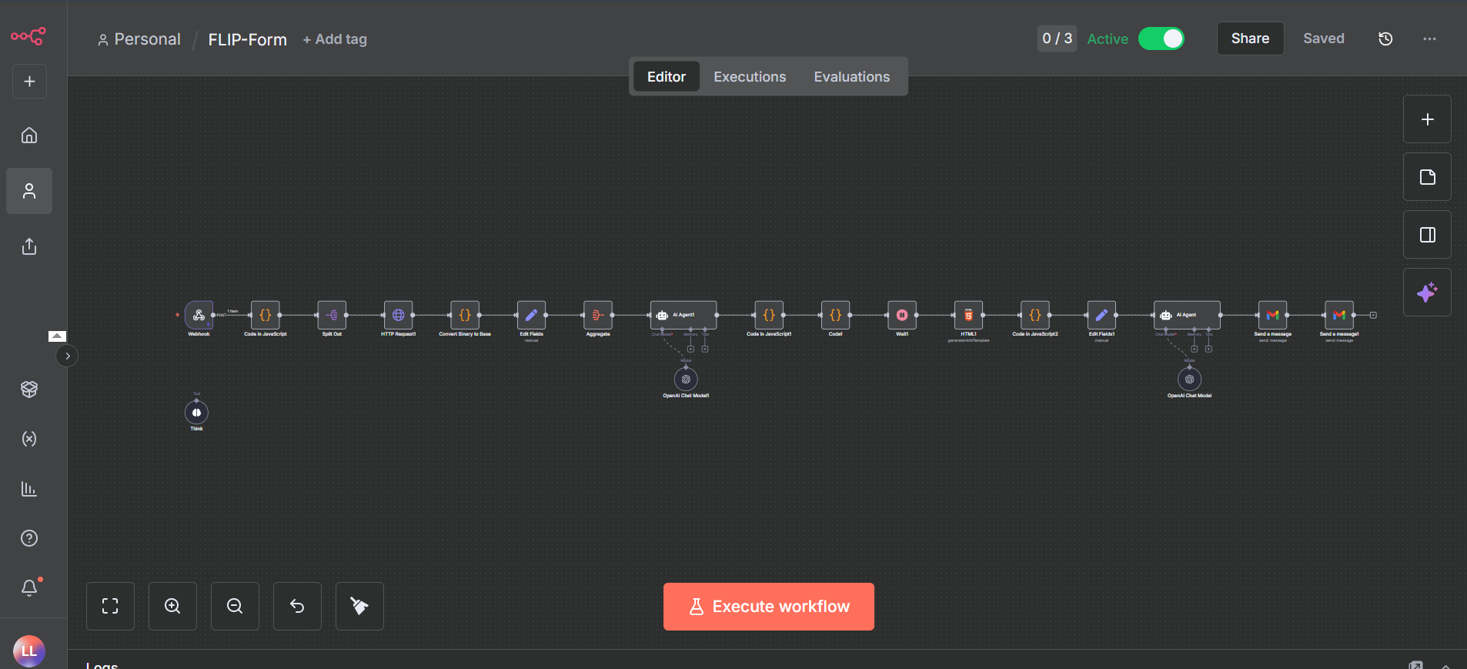
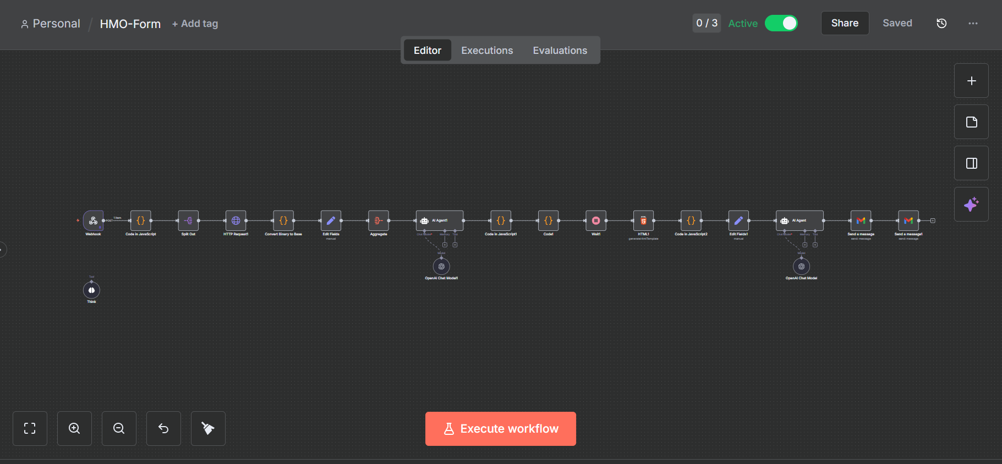
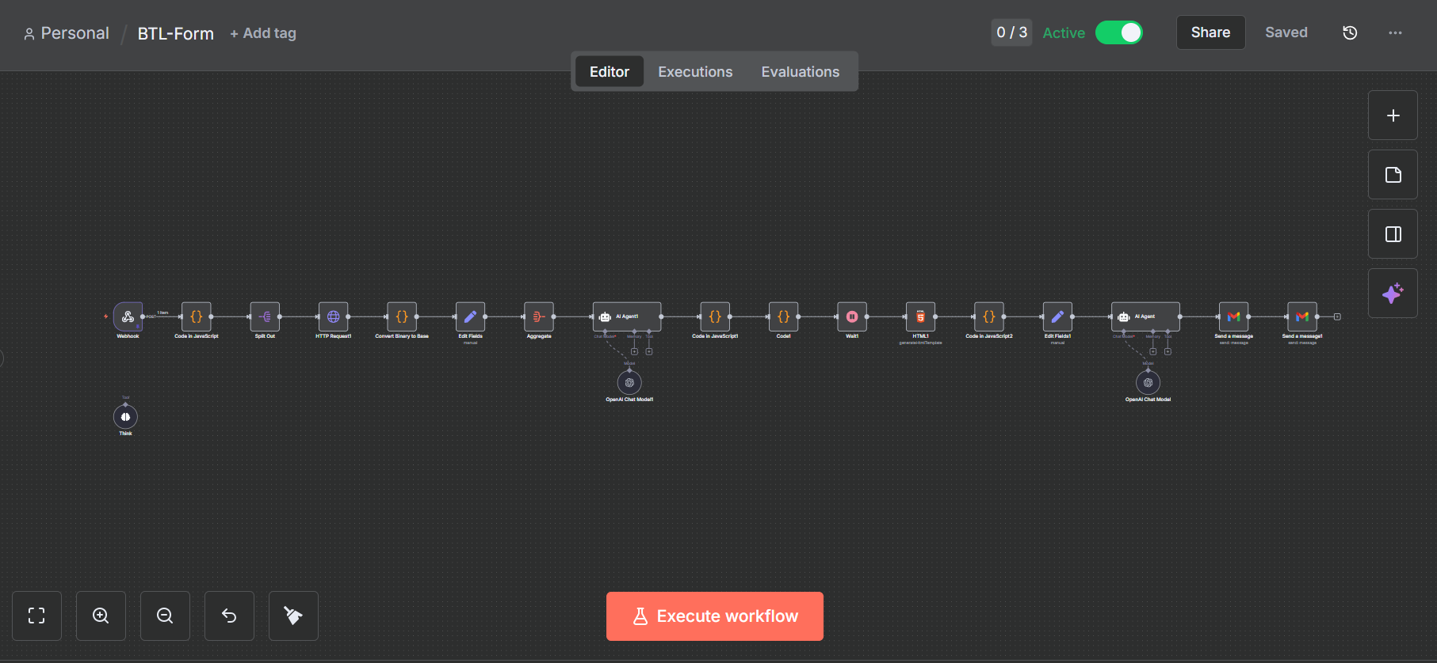
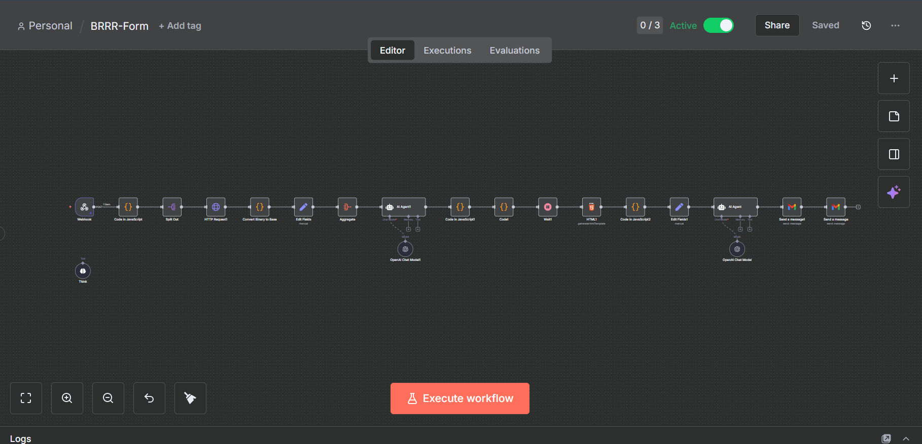

Built an automated system for creating deal specific landing pages for real estate investment opportunities.
The system collects structured deal information, generates a dedicated landing page, stores the deal data, and distributes the opportunity to investors or internal teams.

Deal Intake
The system supports five investment strategies:
• BRRR
• BTL
• HMO
• FLIP
• Rent to Rent
Each strategy has its own dynamic form and captures the relevant property and financial information, including:
• Property details
• Purchase price
• Property type
• Bedrooms and bathrooms
• Rental and resale projections
• Investment figures
• Deal notes

Landing Page Generation
Once a deal is submitted, the system:
• Creates a unique Deal ID
• Generates a dedicated landing page
• Populates the page with the submitted deal information
• Creates a shareable URL
• Presents the opportunity in a consistent format for investors

Data & Distribution
All submitted deals are stored in Google Sheets for tracking and management.
New deals can then be automatically shared with investors, partners, or internal teams through connected notification and communication channels.

Technology
• n8n
• Dynamic web forms
• Google Sheets
• Webhooks
• API integrations
• Landing page automation

Result
A scalable deal publishing system that removes manual landing page creation, standardizes deal presentation, keeps deal information organized, and allows new investment opportunities to be published and shared quickly.

